**Chapter 1**

**Introduction**

*This chapter presents an introduction to the need and motivation for augmented interface, the concept of emerging technologies such as fluid interfaces, augmented reality and Internet of Things. This is followed by a basic description of the project.*

**1.1 Need and Motivation**

In today's society, technology has become a crucial part of our lives. It has changed how people think and apply knowledge. One of the newest developing technologies is fluid Interface which uses reality environments like Augmented Reality. It is the ground-breaking virtual application for advertising, industrial applications, and much more. Augmented reality has been a hot topic in software development circles for a couple of years, but it’s getting renewed focus and attention with the release of products like Google Glass or Microsoft Hololens. This new technology blurs the line between what's real and what's computer-generated by enhancing what we see, hear, feel and smell. Augmented Reality turns the environment around you into a digital interface by placing virtual objects in the real world, in real-time. Augmented Reality can be seen through a wide variety of experiences and has also changed the way we see the world. The idea is to take advantage of these technology to create a security application with an enriched user experience

**1.2 Scope of the Project**

This project has a wide use in commercial and industrial sectors. It can also be implemented on personal level. It provides the users with an enriched experience with the help of augmented reality. At the same time, providing a very high security feature. It provides 3 levels of security.

1. **LOCAL NETWORK** – Network is password protected. This ensures only valid users to access it.
2. **MARKER** – Marker is an image is to detected by the camera. To increase the security, a target image should be such which camouflages with the background environment. This is difficult to be found.
3. **PASSWORD** – The numeric or alpha numeric password in itself provides better security.

**1.3 Introduction to Emerging Technology**

**1.3.1 Fluid Interface**

The Fluid Interfaces research group radically rethinks the way we relate to our personal digital devices. We aim to design systems that are better integrated with a user's body and mind, that augment their experience of daily life and mediate their interaction with the physical world around them. The resulting "human computer symbiotic systems" enable users' personal growth by supporting the way they make decisions, learn and communicate.

We rely on computers and smart mobile devices for nearly every aspect of our lives, yet the way we interact with them has not changed significantly since personal computers were first invented 40 years ago. The Fluid Interfaces research group radically rethinks human-computer interaction with the aim of making the user experience more seamless, natural and integrated in our physical lives. Our goal is to design and develop interfaces that are a more natural extension of our minds, bodies and behavior. We aim to design novel form factors that leverage the full range of sensory capabilities and control modalities of the user while exploring the following themes:

* Interfaces that perceive the user, her current context and actions and offer relevant services and information based on that awareness;
* Interfaces that offer a more natural interaction experience, that allow a user to use the functionality without diverting their attention or disrupting their actions;
* Wearable interfaces that augment the human senses and capabilities;
* Interfaces that are designed for more specific or limited applications making innovative use of their physical shape, size and materials.

These design interfaces that are more intuitive and intelligent, and better integrated in our daily physical lives.

**1.3.2 Augmented Reality (AR)**

Augmented reality (AR) is a live direct or indirect view of a physical, real-world environment whose elements are augmented by computer-generated sensory input such as sound, video, graphics or GPS data. It is related to a more general concept called mediated reality, in which a view of reality is modified (possibly even diminished rather than augmented by a computer. As a result, the technology functions by enhancing one’s current perception of reality. By contrast, virtual reality replaces the real world with a simulated one. Augmentation is conventionally in real time and in semantic context with environmental elements, such as sports scores on TV during a match. It is a technology that works on computer vision based recognition algorithms to augment sound, video, graphics and other sensor based inputs on real world objects using the camera of your device. It is a good way to render real world information and present it in an interactive way so that virtual elements become part of the real world.

Augmented Reality is the ground-breaking virtual application for advertising, industrial applications, and much more.Augmented reality has been a hot topic in software development circles for a number of years, but it’s getting renewed focus and attention with the release of products like Google Glass or Microsoft Hololens. Augmented reality displays superimpose information in your field of view and can take you into a new world where the real and virtual worlds are tightly coupled. It is not just limited to desktop or mobile devices. As mentioned, Microsoft Hololens, a wearable computer with optical head-mounted display, is a perfect example.

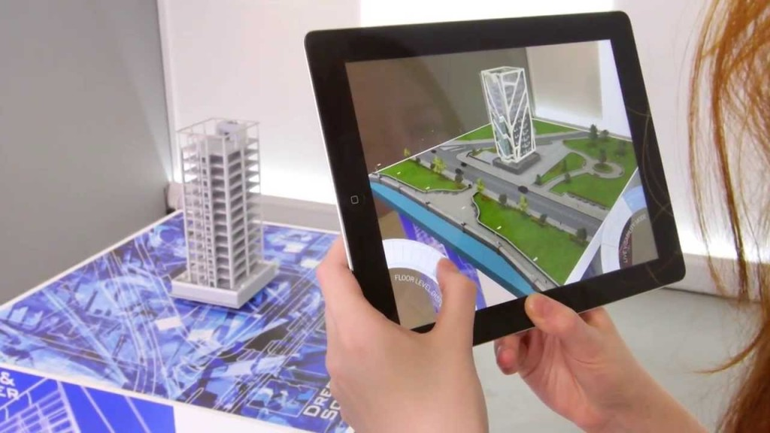

Figure 1.1

**How does it work?**

A simple augmented reality use case is: a user scans the image of a real-world object, and the underlying platform detects a marker, which triggers it to add a virtual object on top of the real-world image and displays the same on your camera screen. With the help of Unity 3d Engine, AR is being used to develop real-time 3D Games. “Augmented Reality bridges the gap between the digital and physical world”.

**1.3.3 Internet of Things (IoT)**

The Internet of Things (IoT) is the network of physical objects or "things" embedded with electronics, software, sensors, and network connectivity, which enables these objects to collect and exchange data. The Internet of Things allows objects to be sensed and controlled remotely across existing network infrastructure, creating opportunities for more direct integration between the physical world and computer-based systems, and resulting in improved efficiency, accuracy and economic benefit. Each thing is uniquely identifiable through its embedded computing system but is able to interoperate within the existing Internet infrastructure. Typically, IoT is expected to offer advanced connectivity of devices, systems, and services that goes beyond machine-to-machine communications (M2M) and covers a variety of protocols, domains, and applications. Besides the plethora of new application areas for Internet connected automation to expand into, IoT is also expected to generate large amounts of data from diverse locations that is aggregated very quickly, thereby increasing the need to better index, store and process such data. On the other hand, IoT systems could also be responsible for performing actions, not just sensing things. Intelligent shopping systems, for example, could monitor specific users' purchasing habits in a store by tracking their specific mobile phones. These users could then be provided with special offers on their favourite products, or even location of items that they need, which their fridge has automatically conveyed to the phone. Another excellent application that the Internet of Things brings to the picture is home security solutions. Home automation is also a major step forward when it comes to applying IoT. All these advances add to the numerous lists of IoT applicatio

Figure 1.2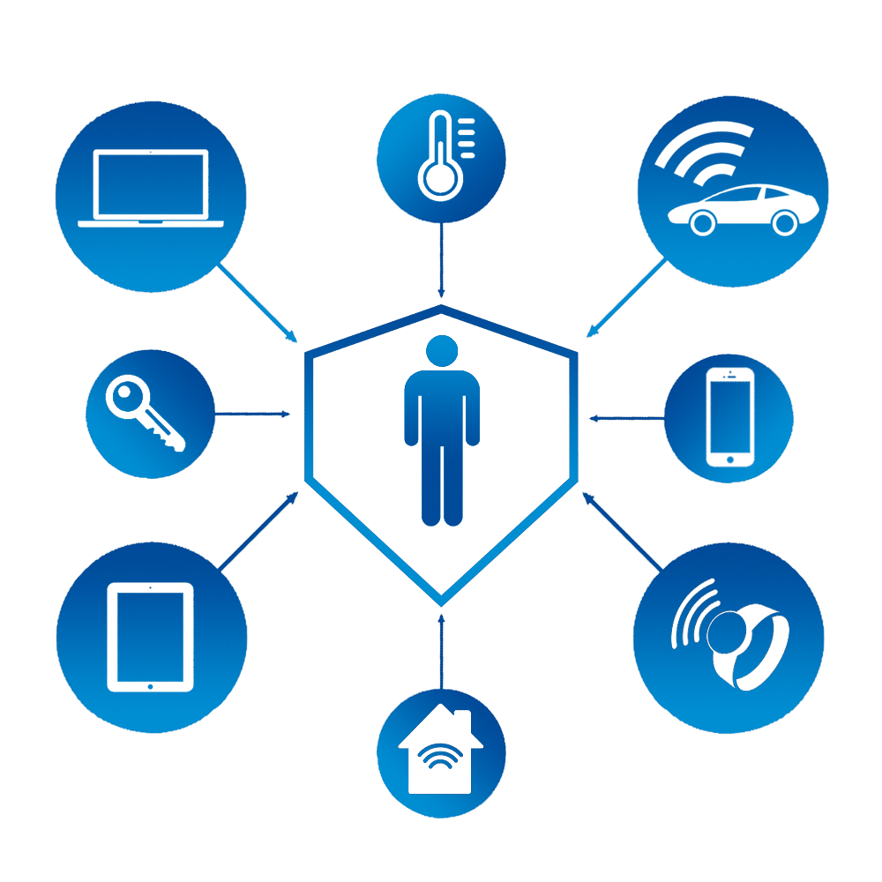

**1.4 Smart Security System Using Fluid Interface with Augmented Reality and IoT**

Conventional physical interfaces such as physical numeric keypads on door and lockers in homes, banks, offices etc. are now turning out to be obsolete, even more, after the advent of the smart-phone. This calls for a revolution of enhanced user experience using ‘AUGMENTED REALITY’.

Security is a major concern in today’s world. There are many existing security systems such as RFID, Smart keys but has still to hit a homerun. Most of the devices are cumbersome to configure and use, and often involves too much of hardware. Also such systems come are not cost effective. Have you thought of securing your house without heavy expense of smart technological systems? Augmented reality eliminates the cost of physical keypad. For instance using RFID keypad to unlock the door is one of the most roundabout and a common way to open a secured door. Have you ever unlocked a door with its lock not visible to you? Trespassers won’t even recognize that there is a 3 level secured system for your door. I believe that lock and other ordinary devices that we are putting "smarts" into needs to add value without taking away the existing value.

**Chapter 2**

**Literature Survey**

*This chapter presents a detailed survey done on the technologies used.*

Augmented reality (AR) refers to systems that add virtual information to the real world. They are becoming a part of everyday life as computing devices become smaller, faster, and more ubiquitous. As this field gains popularity, there are many professional societies dealing with AR and VR research such as ISMAR (International Symposium on Mixed Augmented Reality), IEEE VR (Virtual Reality; formally VRAIS), etc. Their goal is to bring together AR/VR related research projects to a venue where students, faculty and practitioners meet together to share and discuss their projects-aimed at helping users achieve their goals effectively and efficiently.[1]

**HISTORY**

The beginnings of AR, as we define it, date back to Sutherland's work in the 1960s, which used a see-through HMD to present 3D graphics. However, only over the past decade has there been enough work to refer to AR as a research field. In 1997, Azuma published a survey that defined the field, described many problems, and summarized the developments up to that point. Since then, AR's growth and progress have been remarkable. In the late 1990s, several conferences on AR began, including the International Workshop and Symposium on Augmented Reality, the International Symposium on Mixed Reality, and the Designing Augmented Reality Environments workshop. Some well-funded organizations formed that focused on AR, notably the Mixed Reality Systems Lab in Japan and the Arvika consortium in Germany.[2]

**BACKGROUND**

The field of AR research is primarily for human use as it is augmenting or simulating the real world. User studies are crucial in AR research as it represents how users respond to stimuli in the research and helps to match more closely to user needs and requirements that improve the effectiveness or efficiency of the research. A set of evaluation techniques especially in the AR research was introduced. It was a literature survey based on over hundred AR related papers that addresses user study approaches and methods as well as user evaluation types. A structured collection of usability design and evaluation guidelines were presented that synthesized information from a literature survey with many different sources. The significance of considering individual differences was emphasized to be taken into account in conducting research. These include user's experience levels, physical capabilities and limitations and technical aptitudes. A tutorial about conducting experiments with human subjects in the field of AR research were given in the 2004 IEEE AR conference and it is being held almost every year of the conference. This implies the practical significance of integrating the user study into the field of AR research.[3]

**RESEARCH DESIGN**

A research design has been formed to address the question of how AR research has been conducted to meet their users' needs. The main idea for the question was to review AR research papers published in major AR conferences and find a trend[4]. The ISMAR and IEEE VR have been chosen because these are the major societies contributing to in the field of AR and VR research.

A total of four review criteria listed below have been established as the second independent variable.

1. Has the research been done an experiment with any type of participants?

2. Has the experiment been conducted with human subjects? If so, how many subjects were participated in the study?

3. Has the data been collected from the experiment analyzed using statistical analysis?

4. Does the study plan a future usability study?

**Chapter 3**

**Project requirements and Specifications**

*This chapter presents an overview of the working of the project which is explained by the block diagram. It discusses the various hardware and software required for the implementation of the project. The chapter also highlights its specifications.*

**3.1 Block Diagram**

Local Network

Raspberry Pi 3

Device with AR application installed

Servo motor

Figure 3.1

The block diagram is explained in the following sub chapter.

**3.2 Devices with AR application installed**

Augmented Reality can be used on all screens and connected devices, the following are few of the options:

* Through **mobile devices like smartphones and tablets**, Augmented Reality acts like a magic window; through the viewer you can see holograms and manipulate 3D models. Hundreds of Augmented Reality apps are available on iPhone, iPad, and Android.
* On **PC and connected TV players**, Augmented Reality works through a webcam and relayed through the screen. This can be quite cumbersome when you have to manipulate a tracker in front of your screen.
* On **head mounted displays, glasses, and lenses,** Augmented Reality becomes a part of your entire field of view, making for more life-like Augmented Reality experiences. It almost feels like Ironman with the help of Jarvis.

This project is implemented using a phone which contains a back camera, in the phone an android application has been installed. To develop the AR application, the following software’s are used: Vuforia and Unity

**3.2.1 Vuforia**

Vuforia is an Augmented Reality Software Development Kit (SDK) for mobile devices that enables the creation of Augmented Reality applications. It uses Computer Vision technology to recognize and track planar images and simple 3D objects, such as boxes, in real-time. Using this software the target image is registered. This image registration capability enables developers to position and orient virtual objects, such as 3D models and other media, in relation to real world images when these are viewed through the camera of a mobile device. The virtual object then tracks the position and orientation of the image in real-time so that the viewer’s perspective on the object corresponds with their perspective on the Image Target, so that it appears that the virtual object is a part of the real world scene.

**3.2.1.1 Why Vuforia?**

* **Unparalleled Reliability**: Vuforia delivers best-in-class computer vision, ensuring robust and reliable experiences in a variety of environments.
* **Creative Empowerment:** Vuforia offers developers the creative freedom to build unique experiences that reflect brands and drive business results
* **Maximum Reach:** Vuforia supports leading phones, tablets and digital eyewear across Android, iOS and UWP
* **Advanced Vision:** Vuforia can recognize a range of everyday images, objects and environments.

**3.2.1.2 Getting started with Vuforia**

1. **Create a license key for the application:** A license key is a unique ID which is required to create an app in Unity which uses Vuforia. To create a license key, we need to head over to “Develop >> License Manager” and select “Add License Key”. Then fill in the required details, after which select “Next” and then “Confirm”. This will direct us back to the “License Manager” page where the application’s name will appear. On the License Manager page select the application name and then we will get the license key. This key will be used later in Unity.
2. **Create a Database and an Image Targe**t: The next step is to set up an image as a target. We head over to “Develop >> Target Manager” and select “Add Database” and fill in the required details. Next, we will need to add images to the newly made database. So, we select the database and click on “Add Target”. Vuforia supports various kinds of targets like single image, cylindrical, cuboidal, 3D image etc.
3. **Rating of the image**: After a short upload time, the target will be added and a “Download Dataset” option will be available. An important thing to note here is the “Rating”. A good rating means that it can be used for tracking, whereas a bad rating means that the image does not have enough feature points. Let’s download the dataset by selecting “Download Dataset >> Unity editor”. This will generate a Unity package containing trackable information about this trackable database.

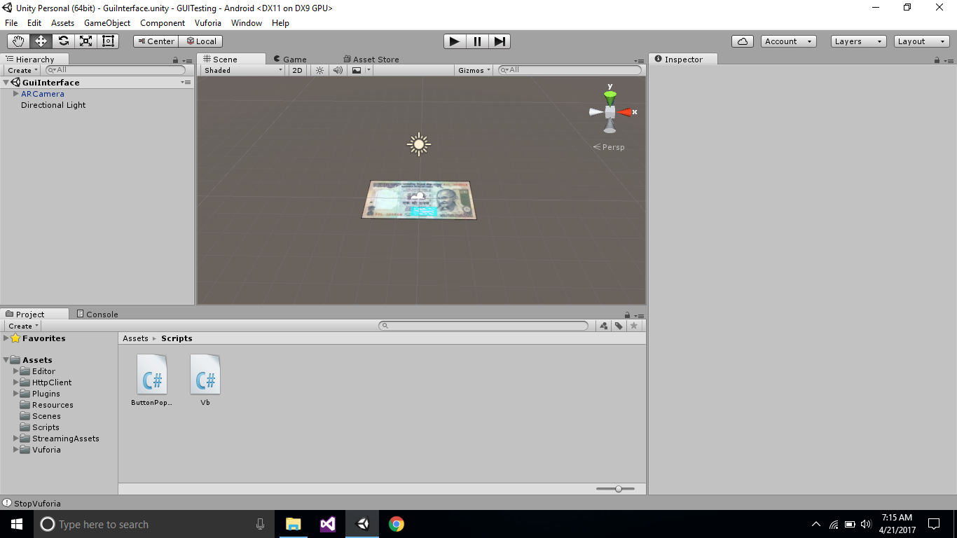

Figure 3.2

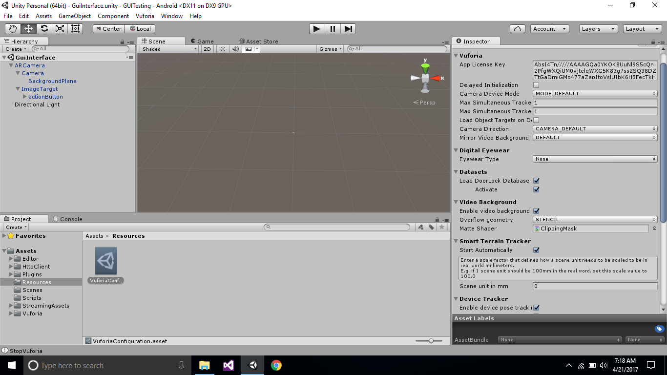

Figure 3.3

**3.2.2 Unity**

Unity is a cross-platform game engine developed by Unity Technologies and used to develop video games for PC, consoles, mobile devices and websites. First announced only for OS X, at Apple's Worldwide Developers Conference in 2005, it has since been extended to target 21 platforms. Nintendo provides free licenses of Unity 5 to all licensed Nintendo Developers along with their software development kits (SDKs) for the Wii U and Nintendo 3DS Family.

You can create any 2D or 3D game with Unity. You can make it with ease, you can make it highly-optimized and beautiful, and you can deploy it with a click to more platforms than you have fingers and toes. What’s more, you can use Unity’s integrated services to speed up your development process, optimize your game, connect with an audience, and achieve success.

**3.2.2.1 Why Unity?**

* Unity is a ready-made solution that’s also intuitive to use.
* It is deeply customizable.
* Rendering power
* 2D and 3D environments available.
* It is highly optimized.

**3.2.2.2 Role of Unity**

Unity is one of the leading platforms to create a 3D environment. The use of this software is made to create a Graphic User Interface (GUI) of a numeric keypad. We make use of C# for the same. After this an android application is made.

**3.3 Raspberry Pi 3**

Raspberry Pi is credit card sized central processing unit of computer developed in United Kingdom for educational purposes. When interfaced with a mouse, keyboard and monitor/TV, it can function as a full-fledged minicomputer. It is programmed using python and can be utilized to develop specific application.

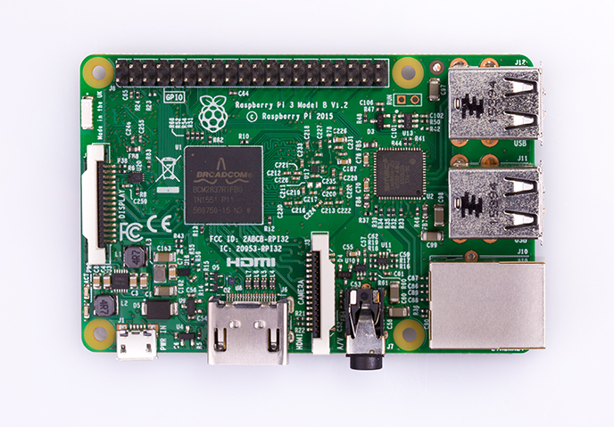

Figure 3.4

The Raspberry Pi 3 Model B is the third generation Raspberry Pi. This powerful board computer can be used for many applications and supersedes the original Raspberry Pi Model B+ and Raspberry Pi 2 Model B. Whilst maintaining the popular board format the Raspberry Pi 3 Model B brings you a **more powerful processor, 10x faster than the first generation Raspberry Pi.** Additionally it **adds wireless LAN & Bluetooth connectivity** making it the ideal solution for powerful connected designs. In-built wireless LAN eliminates the use of ether net, thus reducing the hardware complexity and making the application cost effective.

**3.3.1 Why Raspberry Pi?**

* **Compact:** It is powerful credit card size processing unit (85 x 56 x 17mm) which can be easily used to setup a localized server. It is portable and can be easily powered using a smartphone charger.

* **Environment friendly:** Unlike the big servers which require lots of energy and extensive cooling systems, pi is an energy efficient product and provides a greener ethical alternative.

* **Developer friendly**: raspberry uses python which does not require extensive programming skills and is far less complicated than its counterparts. Also, python has good code readability and automatic memory management function.
* **Connectivity**: The on-board Ethernet port enables to connect internet easily. This facilitates the server setup. The four USB 2.0 ensures a good rate for secure data transfer and is used to interface with various peripherals. There are also 40 GPIO pins for sensors and other hardware.
* **Interaction:** The Pi makes a slew of operations easier to manage, whether you intend to connect to the Internet to read and write data, view media of any kind, or connect to an external display.
* **Open platform:** It requires no special permission or licenses to use the product so as to encourage development of innovative ideas using pi. Hence it is ideal for small database management.
* **Cost:** From the server setup point of view, the cost of raspberry pi is reasonable if compared to the other hardware required for the same setup.

**3.3.2 Technical Specifications:**

|  |  |
| --- | --- |
| System on Chip (Soc) | BCM 2837 |
| CPU | 4× ARM Cortex-A53, 1.2GHz |
| GPU | Broadcom VideoCore IV |
| RAM | 1GB LPDDR2 (900 MHz) |
| Networking | 10/100 Ethernet, 2.4GHz 802.11n wireless |
| Bluetooth | Bluetooth 4.1 Classic, Bluetooth low energy |
| Storage | Micro SD |
| GPIO | 40-Pin header, populated |
| Ports | HDMI, 3.5mm analogue audio-video jack, 4× USB 2.0, Ethernet, Camera Serial Interface (CSI), Display Serial Interface (DSI) |

Table 3.1

**3.3.3 RPi GPIO**

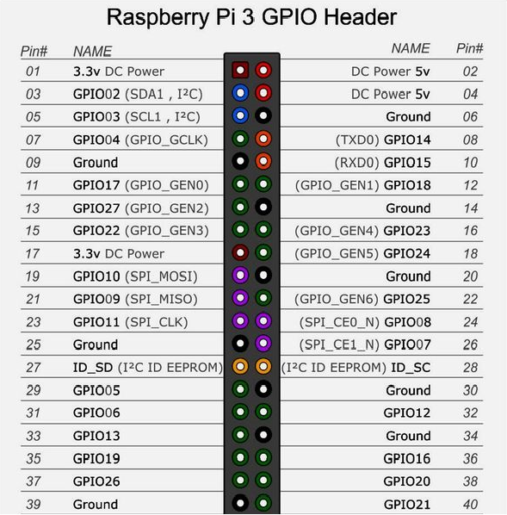

Figure 3.5

**3.3.4 Role of Raspberry Pi**

The password typed by the user on the android application is uploaded to a server. This data is acquired by Rpi and it verifies the password. After the authentication the RPi triggers the servo motor, which is connected to it. The servo motor then rotates 90o to the left to unlock the door.

**3.3.5 Raspbian**

Raspbian is a free operating system based on Debian optimized for the Raspberry Pi hardware. An operating system is the set of basic programs and utilities that make your Raspberry Pi run. However, Raspbian provides more than a pure OS: it comes with over 35,000 packages, pre-compiled software bundled in a nice format for easy installation on your Raspberry Pi. These packages are optimized for best performance on the RPi. This provides significantly faster performance for applications that make heavy use of floating point arithmetic operations.

A Raspbian image is a file that you can download onto an SD card which in turn can be used to boot your Raspberry Pi and Via APC into the Raspbian operating system. Using a Raspbian image is the easiest way for a new user to get started with Raspbian.

**3.3.6 Setting up of the Raspberry Pi**

**Requirements:**

* SD Card – An 8GB class 4 SD card on which NOOBS is to be installed.
* HDMI/ DVI monitor or a TV with HDMI port in it, for displaying the GUI of the Raspberry Pi.
* Keyboard and Mouse – Any standard keyboard and mouse works.
* Power supply – A 5V micro USB power supply to power the Raspberry Pi. A minimum of 5V is required to power it. Less voltage may result in strange behavior. We use a standard Android phone charger to power the RPi.
* Internet Connection – Required for updating or downloading software on the Raspberry Pi.

**3.3.7 Plugging in the RPi**

* Begin by slotting the SD card into the SD card slot on the Raspberry Pi, which will only fit one way.
* Next, plug in the USB keyboard and Mouse into the USB slots on the Raspberry Pi.
* Make sure that the monitor or TV is turned on and that the right input is selected (e.g. HDMI 1, DVI, etc.)
* Then connect the HDMI cable from the Raspberry Pi to the monitor or TV.
* When all the cables and SD card are plugged in as required, plug in the micro USB power supply. This action will turn on and boot the Raspberry Pi.

**3.4 Packages installed on Rpi**

**3.4.1 Wiring Pi**

**Wiring Pi** is a **PIN** based GPIO access library written in C for the BCM2835 used in the **Raspberry Pi**. It’s released under the [GNU LGPLv3](http://www.gnu.org/copyleft/lesser.html) license and is usable from C, C++ and RTB (BASIC) as well as many other languages with suitable wrappers.

The original [Raspberry Pi](http://raspberrypi.org/) Model A and B version B1 was a $35 single board computer with a 26-pin General Purpose Input/Output (GPIO) connector and this carries a set of signals and buses. There are 8 general purpose digital I/O pins – these can be programmed as either digital outputs or inputs. Two of these pins (on 40-pin Pi’s, just one on 26-pin Pi’s) can be designated for hardware PWM output too. Additionally there is a 2-wire I2C interface and a 4-wire SPI interface (with a 2nd select line, making it 5 pins in total) and the serial UART with a further 2 pins.

**3.4.2 Apache HTTP Server**

The Apache HTTP Server, colloquially called Apache, is the world's most used [web server](https://en.wikipedia.org/wiki/Web_server) software. Apache played a key role in the initial growth of the [World Wide Web](https://en.wikipedia.org/wiki/World_Wide_Web). Apache is developed and maintained by an open community of developers under the auspices of the [Apache Software Foundation](https://en.wikipedia.org/wiki/Apache_Software_Foundation).

**3.5 SG90 9G Micro Servo Motor**

A servomotor is a rotary actuator or linear actuator that allows for precise control of angular or linear position, velocity and acceleration. It consists of a suitable motor coupled to a sensor for position feedback. It also requires a relatively sophisticated controller, often a dedicated module designed specifically for use with servomotors.

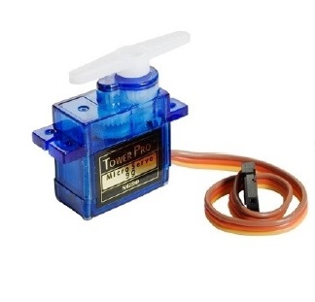

Figure 3.6

Tiny and lightweight with high output power. Servo can rotate approximately 180 degrees (90 in each direction), and works just like the standard kinds but smaller. You can use any servo code, hardware or library to control these servos. Good for beginners who want to make stuff move without building a motor controller with feedback & gear box, especially since it will fit in small places. It comes with a 3 horns (arms) and hardware.

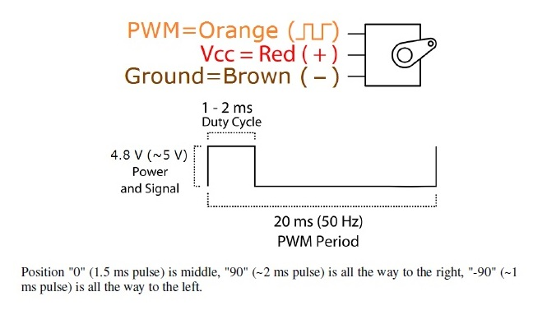

Figure 3.7

**3.5.1 Specifications**

|  |  |
| --- | --- |
| Weight | 9 g |
| Dimension | 22.2 x 11.8 x 31 mm approx. |
| Stall torque | 1.8 kgf·cm |
| Operating speed | 0.1 s/60 degree |
| Operating voltage | 4.8 V (~5V) |
| Dead band width | 10 µs |
| Temperature range | 0 ºC – 55 ºC |

Table 3.2

**Chapter 4**

**Implementation**

*This chapter presents the implementation of the project with the help of a basic flow chart.*

**4.1 Unity**

**Getting started with Unity**

1) Creating a scene

2) Importing package of Vuforia names as **unity sdk**.

3) It consists of AR camera prefab and then we need to configure Vuforia configurations in it by applying the license to access the database which we created on Vuforia.

4) We have an image target prefab into Vuforia package, we add object to that image target which we call as a marker.

5) We create a keypad and then add it as an interface for the user.

6) We have interfaced our keypad with the marker which enables it to augment when the marker is detected.

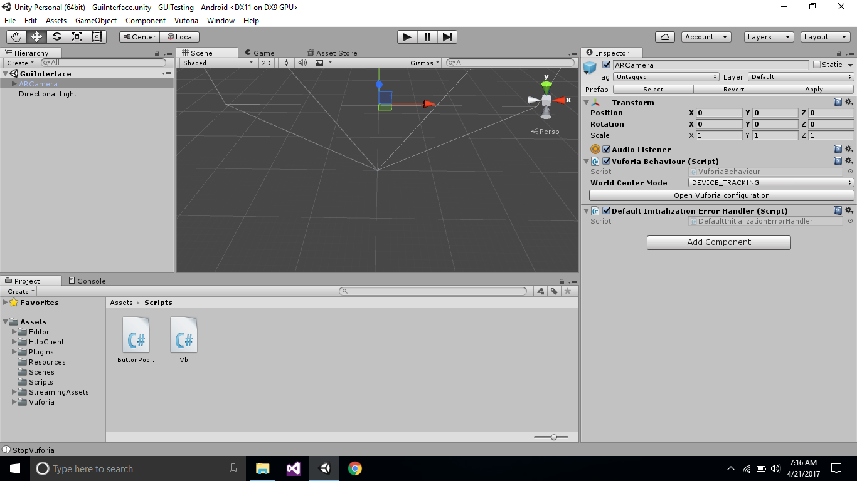

Figure 4.1

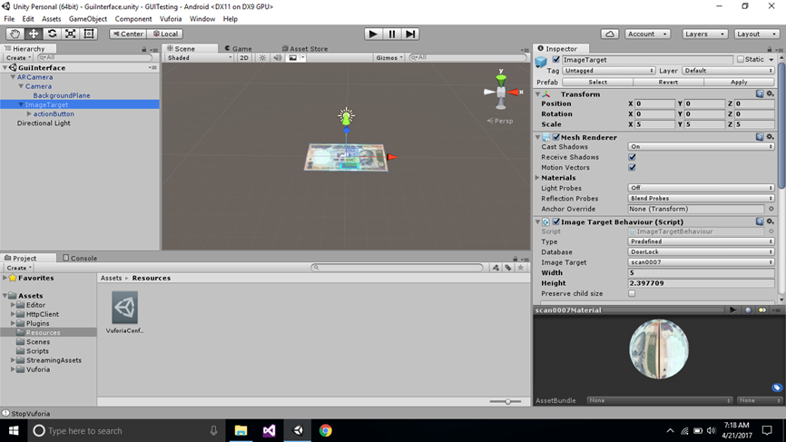

Figure 4.2

**4.2 Building an Android Application:**

1. Unity itself consists of android packages which converts the whole project into an android application which takes the support of android sdk software.

2. Installing android sdk software

3. Then from the build settings in unity we name our android application.

4. Create an icon for the identification of application and make that application under com.company.name.

5. Then we build it.

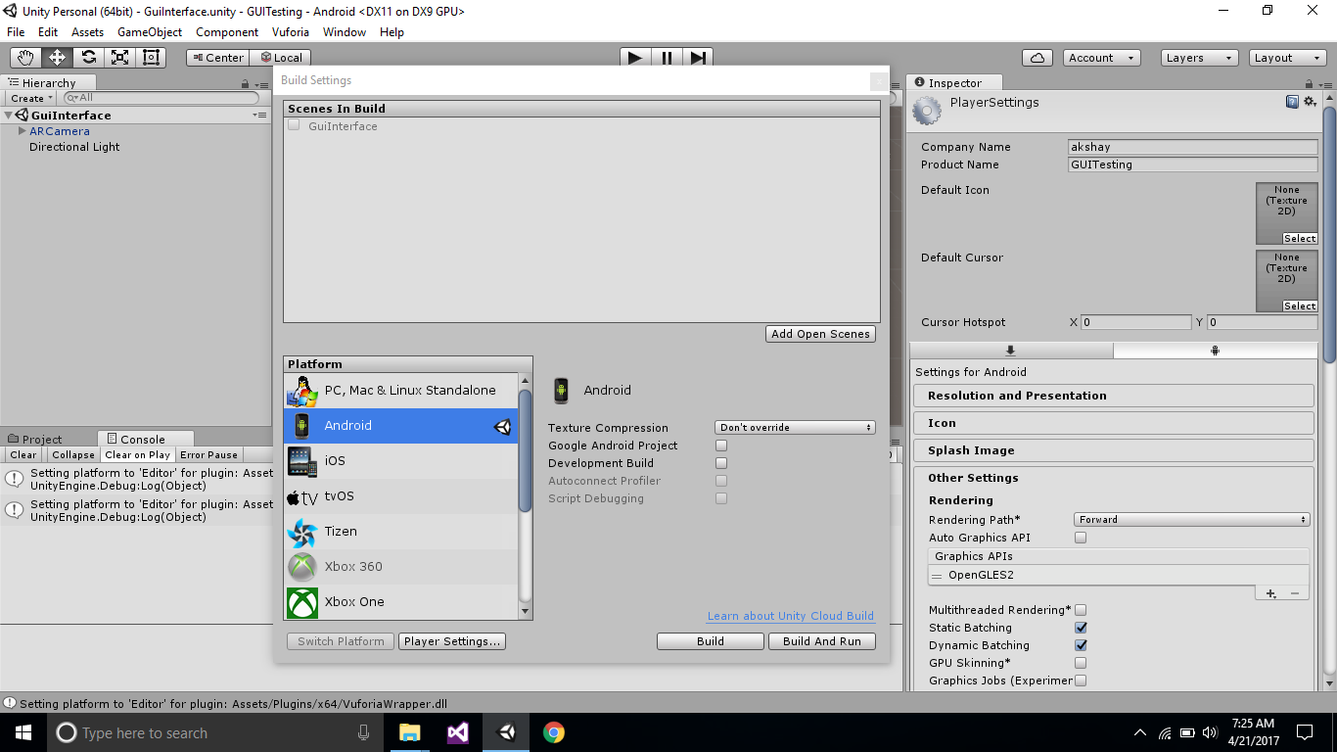

Figure 4.3

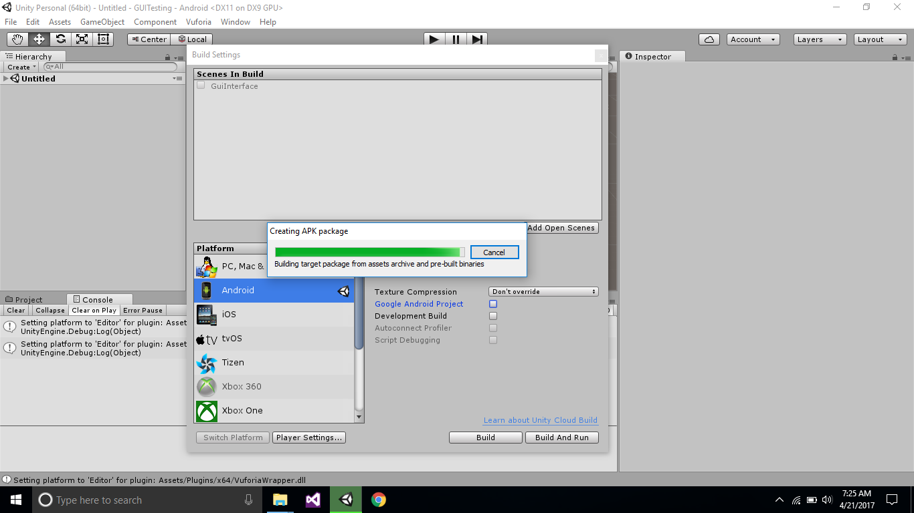

Figure 4.4

**4.3 Packages on Rpi**

**4.3.1 Wiring pi**

**To install:**

First check that wiringPi is not already installed. In a terminal, run:

**gpio -v**

If you get something, then you have it already installed. The next step is to work out if it’s installed via a standard package or from source. If you installed it from source, then you know what you’re doing – carry on – but if it’s installed as a package, you will need to remove the package first. To do this:

**sudo apt-get purge wiringpi**

**hash -r**

Then carry on.

If you do not have GIT installed, then under any of the Debian releases (e.g. Raspbian), you can install it with:

**sudo apt-get install git-core**

If you get any errors here, make sure your Pi is up to date with the latest versions of Raspbian: (this is a good idea to do regularly, anyway)

**sudo apt-get update**

**sudo apt-get upgrade**

To obtain WiringPi using GIT:

**cd**

**git clone git://git.drogon.net/wiringPi**

If you have already used the clone operation for the first time, then

**cd ~/wiringPi**

**git pull origin**

Will fetch an updated version then you can re-run the build script below.

To build/install there is a new simplified script:

**cd ~/wiringPi**

**./build**

The new build script will compile and install it all for you – it does use the sudo command at one point, so you may wish to inspect the script before running it.

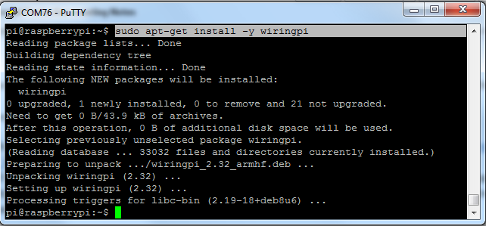

Figure 4.5

**4.3.2 Apache HTTP Server**

**Steps to install Apache:**

To install Apache and PHP, use the following command:

**sudo apt-get install apache2 php5 libapache2-mod-php5**

You will be prompted if you would like to continue, type y for yes and hit enter to continue. This process may take a few minutes.

Then restart Raspberry Pi

**sudo restart**

Now go to your web browser of choice and type the Raspberry Pi's IP address into the URL bar.

You will see the following on your screen

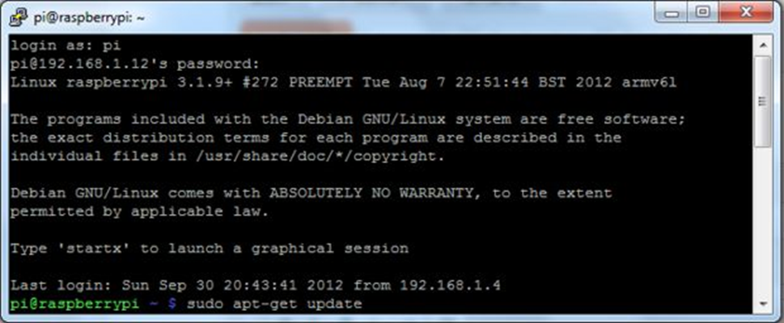

Figure 4.6

**4.3.3 Root Folder Permissions**

To edit and execute a root folder file, required permissions are needed:

From the Root Terminal

You can permission to folder and all contents using option -R i.e Recursive permissions.

Ideally give 755 permission for security reasons to web folder:

**sudo chmod -R 755 /www/store**

Each number have meaning in permission:

N Description ls binary

0 No permissions at all --- 000

1 Only execute --x 001

2 Only write -w- 010

3 Write and execute -wx 011

4 Only read r-- 100

5 Read and execute r-x 101

6 Read and write rw- 110

7 Read, write, and execute rwx 111

First Number 7 - Read, write, and execute for user.

Second Number 5 - Read and execute for group.

Third Number 5 - Read and execute for other.

If your production web folder has multiple users, then you can set permissions and user groups accordingly.

**4.4 POST/GET Method**

**4.4.1 The POST Method**

The POST method transfers information via HTTP headers. The information is encoded as described in case of GET method and put into a header called QUERY_STRING.

• The POST method does not have any restriction on data size to be sent.

• The POST method can be used to send ASCII as well as binary data.

• The data sent by POST method goes through HTTP header so security depends on HTTP protocol. By using Secure HTTP you can make sure that your information is secure.

• The PHP provides $_POST associative array to access all the sent information using POST method.

**4.4.2 The GET Method**

The GET method sends the encoded user information appended to the page request. The page and the encoded information are separated by the ‘?’ character.

• The GET method produces a long string that appears in your server logs, in the browser's Location: box.

• The GET method is restricted to send upto 1024 characters only.

• Never use GET method if you have password or other sensitive information to be sent to the server.

• GET can't be used to send binary data, like images or word documents, to the server.

• The data sent by GET method can be accessed using QUERY_STRING environment variable.

• The PHP provides $_GET associative array to access all the sent information using GET method.

**4.4.3 Implementing POST and GET Method**

These are two ways the browser client can send information to the web server.

• The GET Method

• The POST Method

Before the browser sends the information, it encodes it using a scheme called URL encoding. In this scheme, name/value pairs are joined with equal signs and different pairs are separated by the ampersand. Spaces are removed and replaced with the + character and any other non-alphanumeric characters are replaced with a hexadecimal values. After the information is encoded it is sent to the server.

Thus we use post method to post data from Unity (client) to the web server. Then we use get method to get data from Raspberry Pi to the web server.

**4.5 Interfacing RPi and Servo Motor**

**4.5.1 Servo Motor**

The position of the servo motor is set by the length of a pulse. The servo expects to receive a pulse roughly every 20 milliseconds. If that pulse is high for 1 millisecond, then the servo angle will be zero, if it is 1.5 milliseconds, then it will be at its centre position and if it is 2 milliseconds it will be at 180 degrees.

The end points of the servo can vary and many servos only turn through about 170 degrees. You can also buy 'continuous' servos that can rotate through the full 360 degrees.

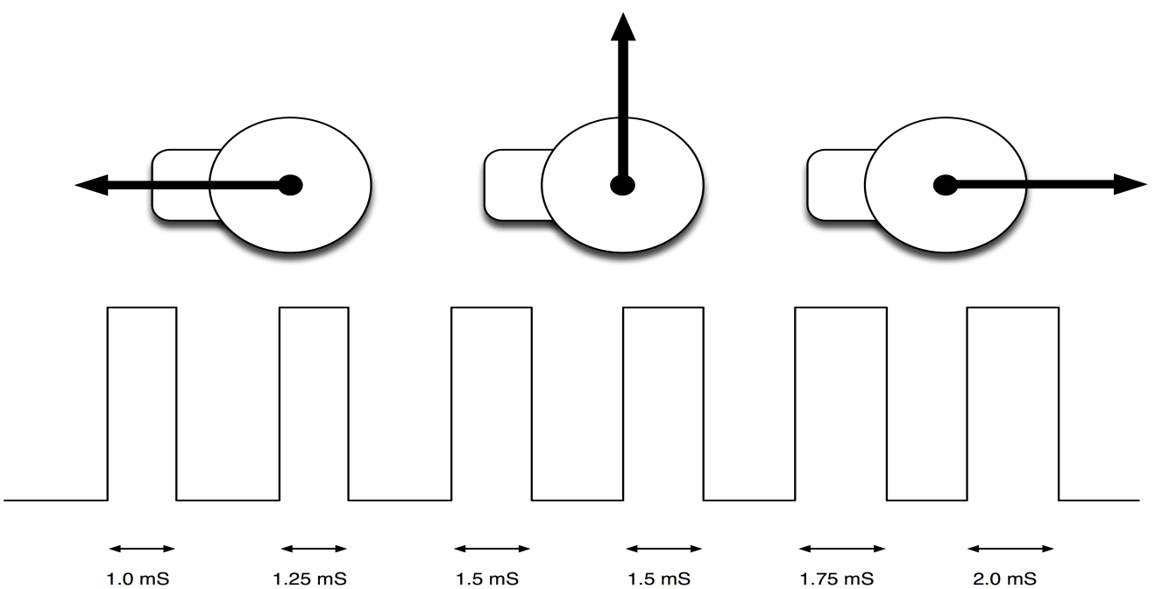

Figure 4.7

**4.5.2 Programming the servo motor**

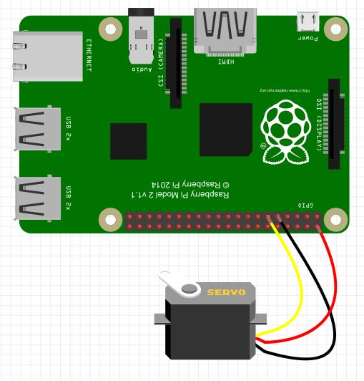

Figure 4.8

Set pin #18 to be a PWM output

**gpio -g mode 18 pwm**

Pin #18 has PWM output, but you have to set it to be the right frequency output. Servo's want 50 Hz frequency output

For the Raspberry Pi PWM module, the PWM Frequency in Hz = 19,200,000 Hz / pwmClock / pwmRange

If pwmClock is 192 and pwmRange is 2000 we'll get the PWM frequency = 50 Hz (thx to kev for the numbers!)

Now you can tell gpio to set the PWM clock to those numbers:

**gpio pwm-ms**

**gpio pwmc 192**

**gpio pwmr 2000**

Now you can set the servo to all the way to the left (1.0 milliseconds) with

**gpio -g pwm 18 100**

Set the servo to the middle (1.5 ms) with

**gpio -g pwm 18 150**

And all the way to the right (2.0ms) with

**gpio -g pwm 18 200**

Servos often 'respond' to a wider range than 1.0-2.0 milliseconds so try it with ranges of 50 (0.5ms) to 250 (2.5ms)

.

**4.6 Model Structure**

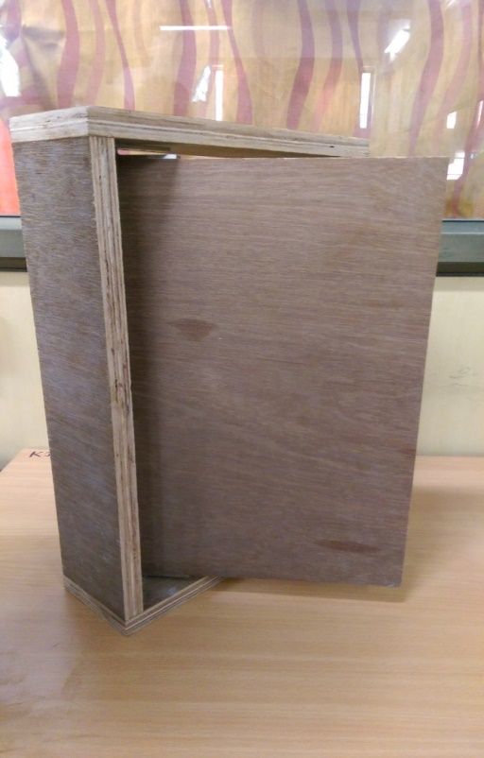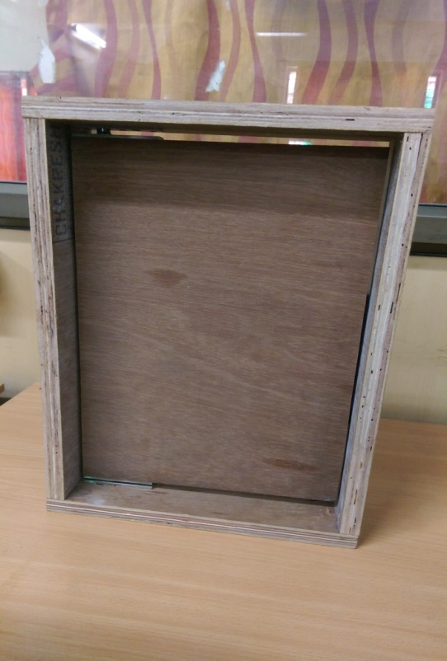

Figure 4.9 Figure 4.10

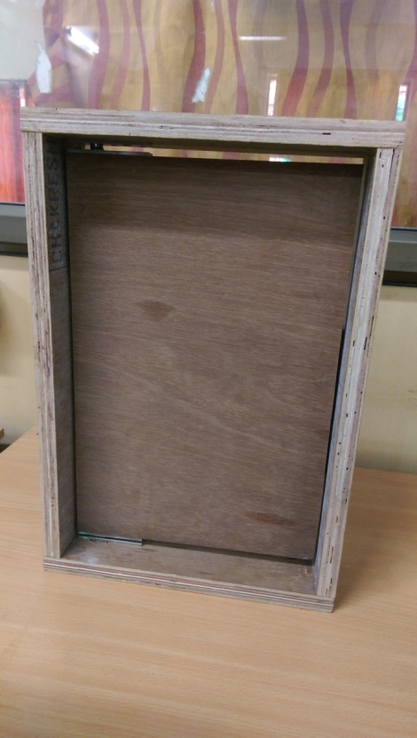 Figure 4.11

**4.7 User experience**

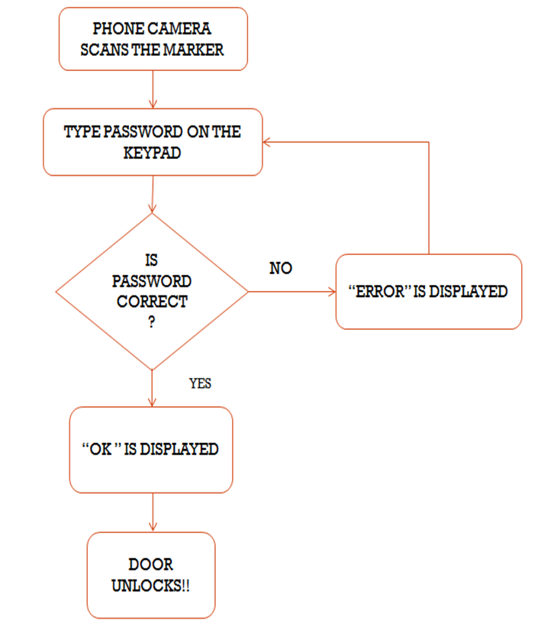

Figure 4.12

Thus this application gives an enhanced user experience. The backend flow of the same is explained below:

1. Using the android application in the phone, scan the marker on the door.
2. On verifying the marker, a keypad appears on the screen.
3. Type the password now.
4. This password is sent to the server for authentication
5. Raspberry Pi verifies the password.
6. When authenticated, the raspberry pi triggers the servo motor.
7. Servo motor rotates 90 degree to the left to unlock the door.
8. Servo motor automatically resets itself after preset time

**Chapter 5**

**Results of the Implementation**

*This chapter shows the final setup of the project along with the screenshots of outputs at the final stage of implementation.*

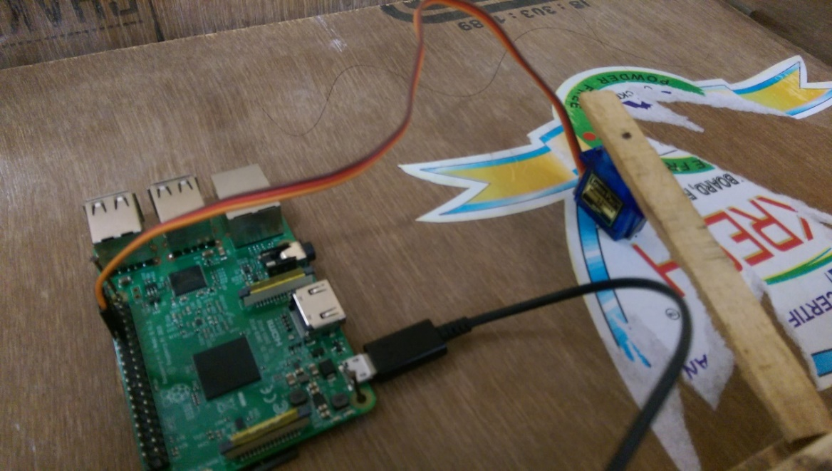

Figure 5.1

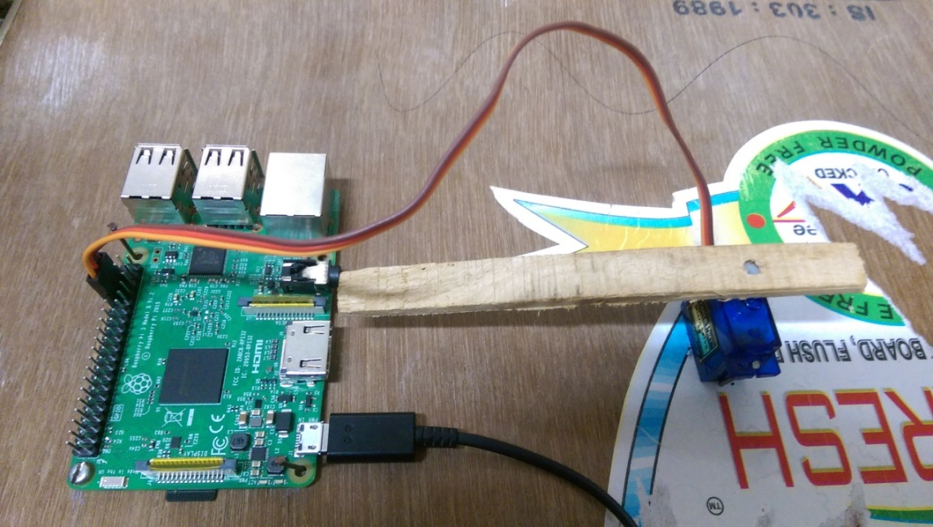

Figure 5.2

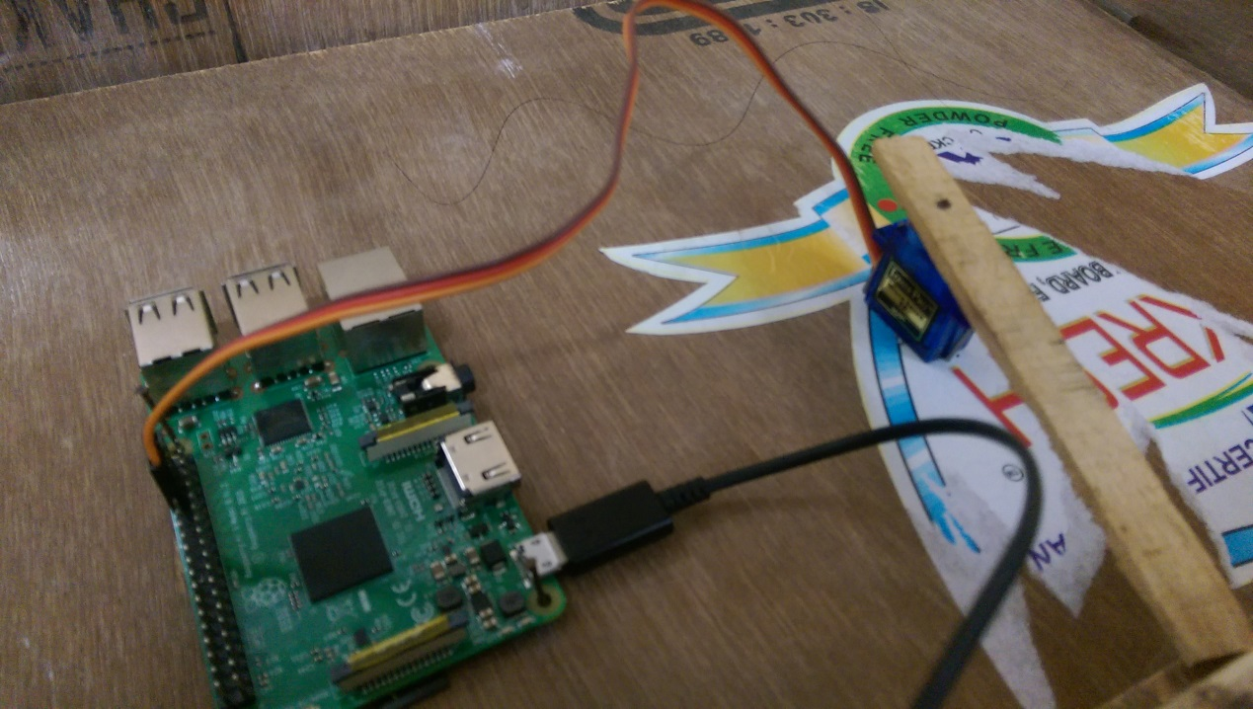

Figure 5.3



Figure 5.4

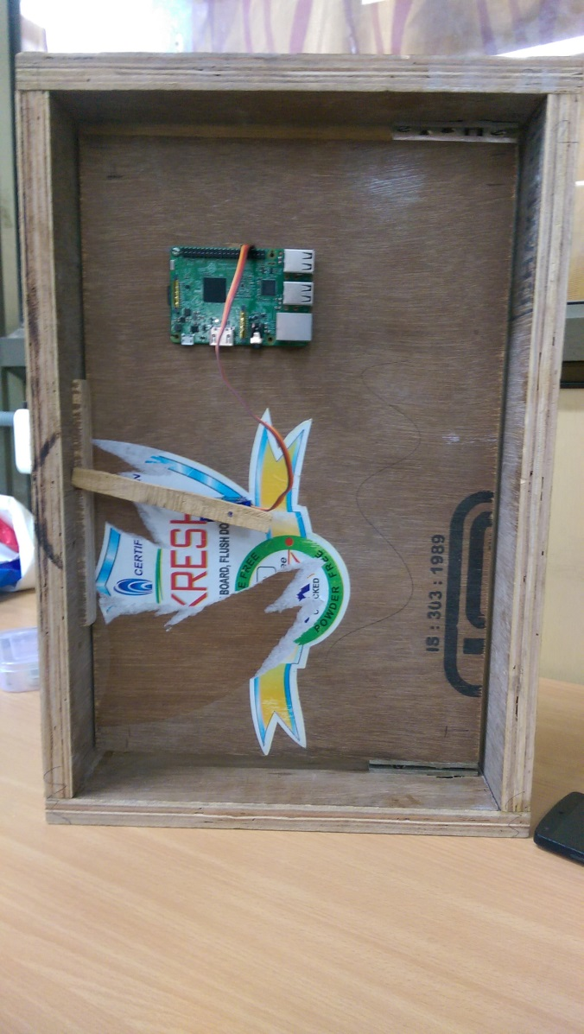

Figure 5.5

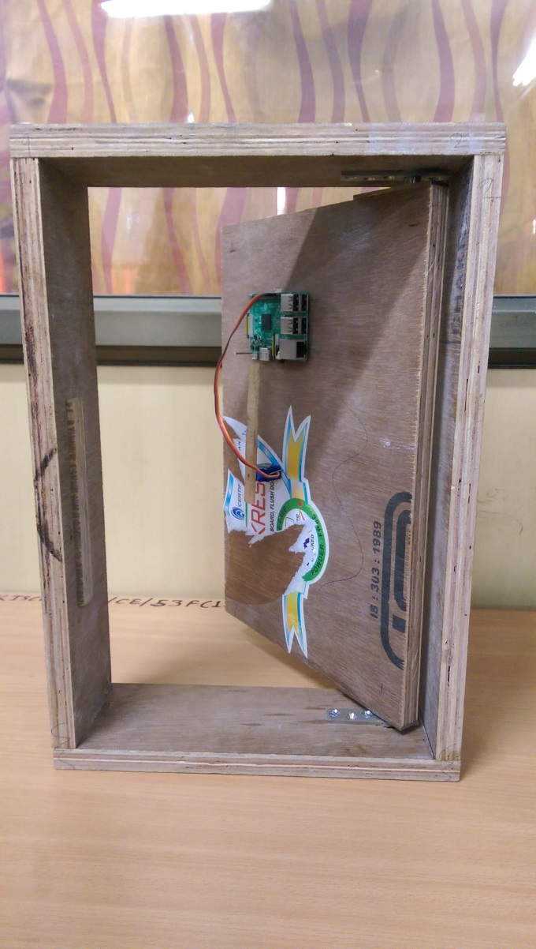

Figure 5.6

**Chapter 6**

**Applications and Future Scope**

*This chapter includes application of the project and future scope. This is followed by conclusion of the project.*

**6.1 Future Scope:**

There are literally hundreds of examples of very cool augmented reality apps, tools and innovations out there. It would be easy to link through to the cream of the crop and simply say “wow, aren’t these awesome?”, but this ‘wow’ factor can only last so long before you have to take a step back and consider what their actual functions are.

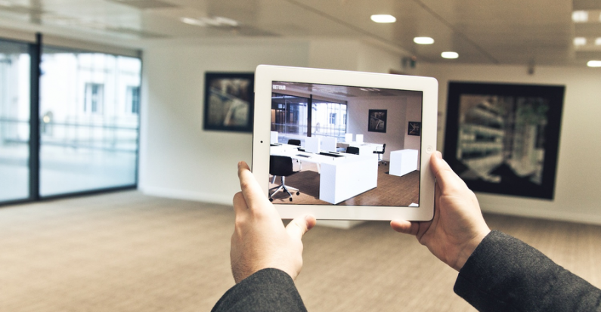

Figure 6.1

Waving a smartphone or tablet in front of an object is already producing some truly inspiring results for current AR users, but it doesn’t always seem like the most practical way of doing things – it would seem that a pair of AR-enabled glasses would be a lot easier to use. However, Blippar’s Rish Mitra thinks the next big developments in AR probably won’t be goggles or glasses. He says:

“The next big thing in AR will still be via smartphones, and we will see developments in the field of image, object, colour recognition. There’ll be few verticals in the area where startups will find niche uses of this technology. Also, location layers and image recognition might merge to give users a more wholesome experience. In terms of beyond mobile, I do believe an AR eye-lens and glasses will evolve, but the gear needs to be lightweight, attractive and comfortable to wear.”

In the academic sphere, Helen Papagiannis, a designer, artist and PhD researcher specializing in augmented reality, has been working on some pretty cutting-edge concepts for using AR technology. She recently developed the first AR pop-up book for mobile devices.

So, augmented reality has the potential to affect all industries and walks of life, from advertising and marketing, to gaming and medicine.

Augmented reality at present still largely feels as though it’s finding its feet, finding a niche and, ultimately, finding a purpose. But there are clear signs of the direction in which it’s heading.

**6.2 Conclusion**

*This chapter includes application of the project and future scope. This is followed by conclusion of the project.*

Augmented reality is another step further into the digital age as we will soon see our environments change dynamically either through a smartphone, glasses, car windshields and even windows in the near future to display enhanced content and media right in front of us. This has amazing applications that can very well allow us to live our lives more productively, more safely, and more informatively.

Maybe in the future, we will see our environments become augmented to display information based on our own interests through built-in RFID tags and augmentations being implemented through holographic projections surrounding the environments without a use of an enabling technology. It would be incredible to no longer wonder where to eat, where to go, or what to do; our environment will facilitate our interactions seamlessly.We will no longer be able to discern what is real and what is virtual, our world will become a convergence of digital and physical media.

Thus AR will in future offer a bunch of new opportunities, products and solutions.

**REFERENCES**

[1] Ubiquitous Virtual Reality (ISUVR), 2012 International Symposium on

Author: Si Jung Jun Kim - Sch. of Visual Arts & Design, Univ. of Central Florida, Orlando, FL, USA

[2] IEEE Computer Graphics and Applications (Volume: 21, Issue: 6, Nov/Dec 2001)

Authors: R Azuma, Y Baillot, R Behringer, S Feiner, S Julier, B MacIntyre

[3]R. Azuma, ìA Survey of Augmented Reality, Presence: Teleoperators and Virtual Environments vol.6, no. 4, Aug. 1997, pp. 355-385.

[4] R. Behringer, ìRegistration for Outdoor Augmented Reality Applications Using Computer Vision Techniques and Hybrid Sensors,î Proc. IEEE Virtual Reality í99.Houston, TX, 13-17 Mar. 1999, pp. 244-251.

\

**ACKNOWLEDGEMENT**

It is a great pleasure to get this opportunity and sincerely thank all people who are directly and indirectly related to this project.

We sincerely thank and express my professional gratitude to our Head of the Department MRS. SANGEETA KULKARNI.

We would like to thank our project guide MS. CHAITALI INGALE for her constant source of inspiration.

We are highly obliged to the teaching and non-teaching staff of ELECTRONICS AND TELECOMMUNICATION DEPARTMENT.